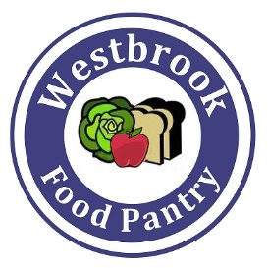
Westbrook Food Pantry
Wish List
Canned Soup
Canned Fruit
Canned Tuna/Salmon/Chicken
Cereal
Macaroni & Cheese
Bottled Juice
1-2 lb package rice
Dried Lentils
Toothbrushes
Toothpaste
Deoderant
Bar Soap
Dish Soap
Laundry Detergent
Stuffing Mix
Cranberry Sauce
Gravy
4 lb bags of sugar
4 lb bags of flour
Vegetable Oil

